CRC Drill Toolkit – Symptomology Cards

Instructions for Use

September 2015



## Basic Concept

To drive drill play, the CRC Toolkit includes two types of Symptomology Cards: **Actor Cards** and **Contamination Cards**. The Actor Cards describe the demographic, situational, and behavioral characteristics of individuals presenting at the CRC, and the Contamination Cards provide simulated radiological data for those individuals.

People going through the Community Reception Center (CRC) will receive one of each card type, with the combination of the two cards providing a snapshot of a person’s situation: characteristics, contamination status, symptoms, behaviors, etc.

The Toolkit includes 100 pre-populated Contamination Cards and 105 pre-populated Actor Cards. The cards are designed to be printed on one-sided paper or card stock and cut and folded according to the lines on the page (Contamination Cards) or in half (Actor Cards). This enables the cards to be easily produced without the need for duplex printing capability. The cards can be printed in color or in black and white. The cards can also be laminated, but it is not necessary to do so.

## Actor Cards

Actor Cards provide the all of the *non-radiological* information about individuals presenting at the CRC. This includes basic demographics and other relevant characteristics, as well as any behaviors, signs, or symptoms taking place. In some cases, Actor Cards may instruct an Actor to basically portray himself/herself (age, gender, etc.). In other cases, Actor Cards may call for a greater level of acting. For example, a card may call for the Actor to portray someone who does not speak English, is upset or fearful, or any of a number of other possibilities CRC staff might encounter in a real emergency situation. The Actor Card provides an Actor with all the information he or she needs to effectively play the role of someone going through the CRC, except for the radiological contamination data. (That information is provided on the Contamination Card, discussed below.)

The front side of an Actor card has three sections. The first section provides the number of the card (from 1 to 105). The second section furnishes basic demographic details such as the person’s age and gender, as well as any other relevant information (e.g., that the person is hearing-impaired). The third section indicates whether the person is experiencing any unusual signs, symptoms or behaviors. The back side of the Actor Card provides the person playing the role with detailed information on how to behave, what to say, how to interact with drill participants, etc. For examples of Actor Cards, see Appendix A.

### Drill Planning Considerations

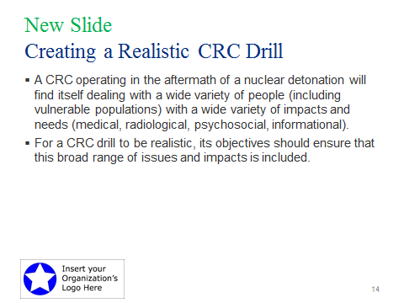**Drill Size**: The Toolkit includes a total of 105 Actor Cards in both Adobe Acrobat and Microsoft PowerPoint (editable) formats. A smaller drill might use the 105 cards (or perhaps even a portion of them) only once, while a larger drill might use the full deck of Actor Cards more than one time to simulate a large number of people (perhaps several hundred) going through the CRC. Also included in the Toolkit is a set of blank Actor Cards. Drill planners can use these either to add to the total number of people going through the CRC (indicating on the cards that Actors should play themselves) or to create new or additional types of simulated affected individuals. The information in the Actor Card deck is also contained in the Actor Card Spreadsheet to aid the Drill Planning Team in reviewing the content of the cards.

**Generic Cards**: Cards 1–16 are “generic” cards that direct the answers to simply play themselves, without any special needs or situations. Planners should choose the ratio of generic cards to cards for special/vulnerable populations (see below) based on their goals for the drill and reproduce the generic cards if more are needed.

Special/Vulnerable Populations: To practice recognizing and meeting the needs of special/vulnerable populations, the Toolkit includes not only a substantial number of generic Actor Cards but also a wide variety of Actor cards simulating special/vulnerable populations. These include children (who make up about 25% of the U.S. population); people with disabilities (who make up about 20% of the U.S. population); senior citizens; individuals with medical or mental health issues; and individuals who are pregnant, breastfeeding, or have reproductive concerns. Also represented in the special/vulnerable population cards are non-English speakers, people with pets, and other groups that might have special needs or concerns.

To facilitate the process of including a wide variety of people, issues, and challenges in the drill, the 105 Actor Cards are organized as follows:

Card Numbers Description

1–20 General

21–29 Medical/First Aid Issues

30–37 Medical Radiological Issues

38–48 Access and Functional Needs/Disabilities

49–55 Child

56–64 Senior

65–71 Pregnant/Breastfeeding/Reproductive Issues

72–75 Language/Literacy Issues

76–84 Psychosocial Issues

85–90 Pet-related Issues

91–96 Information Needs

97–98 CRC Operations Issue

99–102 CRC Security Issue

103–105 CRC Staff Problem/Concern

Note: *To ensure that a drill is realistic, drill planners should be sure to include Actor Cards from all of the groups listed above.*

### Actor Controller

### The Actor Cards are distributed by the Actor Controller, who will discuss their use at the Actor Orientation. Should an Actor have questions about the cards or a role, or if an Actor has concerns about what he or she is being asked to do, these should be brought to the attention of the Actor Controller.

### Use of the Actor Cards during Drill Play

Actors should play the role indicated on the Actor Card, using the Card information to complete the CRC registration process. Actors should avoid going beyond what is on the cards. For example, Actors should not ad lib (make up) symptoms or situations not on the card or directed to them by a controller. Actors should avoid overacting, but they should make their actions obvious enough for CRC staff to have an opportunity to take notice. To help CRC staff players notice physical characteristics that in a real situation would be obvious without having to interact with an individual, Actors can wear sticky labels near their badges indicating such characteristics (e.g., “child,” “wheelchair,” “elderly”). If the CRC staff players do not recognize an Actor’s behaviors, symptoms, or the situation being portrayed, an Actor may increase the intensity of symptoms, agitation, etc. as might occur in real life. Actors should not prompt the CRC staff players.

Note that cards 97, 98, 103, 104, and 105, differentiated with yellow highlighting in the “Characteristics” box, should be given to CRC staff players to act out, rather than to volunteer actors.

After an Actor finishes the CRC process and passes through the Discharge Station, the Actor should return to the Actor Controller to turn in the cards. Depending on the size of the drill, the cards may be reused. Likewise, Actors may be given a new set of cards so that they can proceed again, in a different role, through the CRC.

## Contamination Cards

The “Contamination Cards” are used by radiological controllers to provide simulated contamination readings to CRC staff conducting radiological monitoring operations. The cards are an effective way to present the radiological data needed to properly evaluate the performance of the radiological portion of the CRC. The front side of the card provides a graphical depiction of the body areas contaminated, and the back side provides simulated meter readings for the three most commonly used hand-held radiation detection instrument types. See Appendix B for an example of the Contamination Cards.

### Drill Planning Considerations

The drill planners must determine the appropriate number of people (actors) who need to pass through each station in the CRC to effectively evaluate the various functions. This includes actors to represent people needing to be monitored, decontaminated, re-monitored after decontamination, and registered as well as those given medical evaluation or intervention. CRCs may vary significantly in size among jurisdictions, so it is important to first determine the capacity of the specific site being drilled. It is recommended that there be 60–75 actors per every 300 affected people to be portrayed.

The planners must also determine the ratio of contaminated to clean actors needed:

* If drill play will focus on the receiving and monitoring stations, a lower ratio (15–25%) of actors should be contaminated. The lower ratio will help prevent backups from a potentially understaffed decontamination station.
* If drill play will focus on the decontamination stations, the ratio should be much higher (75–85%).
* If all stations are being drilled and evaluated equally, the ratio should be more balanced (near 50%).[1]

The Actor Cards include people with Acute Radiation Syndrome; if these cards are used, those actors will also need to have Contamination Cards showing high contamination levels.

The Toolkit includes 100 contamination cards in both Adobe Acrobat and Microsoft Publisher formats. The cards are grouped in two sets of 50; each set includes cards with differing contamination levels on various body parts. A small drill might only use one set (or part of a set), while a larger drill might use both sets and even require planners to duplicate the sets to meet the required number of contaminated persons. A set of blank cards is included for the non-contaminated persons. Drill planners can also use these blank cards to create their own cards to drive specific actions.

### Radiological Controllers

Each radiation monitoring lane during the drill should have an assigned Radiological Controller. This controller will be responsible for providing information (simulated instrument readings) to CRC radiological monitoring staff. The Radiological Controller will provide the readings from the card verbally as the frisking is in progress. The Radiological Controller will assess the monitoring staff’s monitoring technique to determine whether the reading has been “earned” (see next section). The players will be informed about this process during their pre-drill briefing. The Contamination Cards are a drill tool for the use of the Radiological Controller and must not be shared with the CRC staff players.

The Lead Radiological Controller is responsible for assigning contamination cards to actors, coordinating the duties of other Radiological Controllers, and answering radiological questions and resolving issues, as needed. The Lead Radiological Controller must coordinate closely with the Lead Controller for the drill and receive feedback from other Radiological Controllers to increase or decrease rate of assigning cards with contamination to actors.

### Use of the Contamination Cards during Drill Play

Radiological Controllers at the Contamination Screening Station will observe the frisking technique and provide a simulated meter reading when it is earned. For a reading to be earned, all of the following conditions must be met:

* The instrument must be turned on.
* The instrument must have a good battery.
* The instrument must be in good operational condition.
* The instrument must be satisfactorily checked with an appropriate radiological source.
* The monitor must use proper frisking technique (appropriate probe distance and speed).

The contamination levels listed on the cards are for exposed skin. If the outer layer of clothing is able to be removed without cross contaminating other body parts, the Radiological Controller will tell the CRC staff monitor that the readings for the previously covered body parts are to be “as read.” “As read” means that the radiation monitors must record the levels they are actually reading on their instruments.

Drill play assumes that the cards reflect actual instrument readings and are not necessarily an indication of the activity or specific isotopes on the skin. The derivation of specific instrument readings is not important, because the drill is designed to evaluate the performance of the monitoring staff and not the accuracy of the instruments.

Radiological Controllers at the Decontamination Station will observe the technique used by the decontamination team. They will need to pay close attention to the technique used to decontaminate specific body areas and determine if the contamination spreads to other areas. In addition to observing for proper monitoring technique, the controller will determine and provide a post-decontamination reading that is reduced from the initial contamination level based the effectiveness of the decontamination technique used. For example, a 50% effective decontamination of 15,000 counts per minute (cpm) will be reported as 7,500 cpm.

## Special Situations

Portable Radiological Portal Monitors: The portal monitors are very sensitive and alarm at low activities (1 µCi of Cs-137). For the purpose of this drill, any contamination noted on a card will be sufficient to set off the portal monitor. Blank cards will be reported as “as read.”

Contaminated Probes: If a controller observes a probe getting contaminated (e.g., a probe touches a contaminated surface), subsequent readings must reflect an appropriate level of contamination until the probe is replaced or decontaminated. The recommended level of probe contamination is 10% of the contaminated surface contacted (e.g., if the contaminated surface is 3,000 cpm, the contamination on the probe will be 300 cpm, and that becomes the new background reading for the probe).

Incorrect Scale: For instruments that are not self-scaling, the controller will give a reading of “off-scale” for scales that are below the contamination level. For example, a contamination level of 15,000 cpm will be reported as “off-scale” for a scale of 100 to 1,000 cpm. For scales that are above the contamination level, the reading will be reported as “as-read.” For example, a contamination level of 50 cpm will be reported as “as-read” for a scale of 100 to 1000 cpm.

Defective Instrument: Controllers will report readings from defective or turned-off instruments as “as-read.” Defective instruments include those that have failed radiological source checks.

Appendix A: Examples of Actor Cards

Actor Cards provide all of the *non-radiological* information about individuals presenting at the CRC. This includes basic demographics and other relevant characteristics, as well as any behaviors, signs or symptoms taking place. The Actor Card provides an Actor with all the information he or she needs to play the role of someone going through the CRC, except for the radiological contamination data.





**Front of Actor Card**

1. The first section provides the number of the card (from 1 to 105). The cards provided in the Toolkit are numbered, and an Excel spreadsheet provides an index to allow the drill planners to select specific cards if they do not plan to use the entire card set, or if they wish to re-use specific types of card.
2. The second section furnishes basic demographic details such as the person’s age and gender, as well as any other relevant information (e.g., that the person is hearing-impaired).
3. The third section indicates whether the person is experiencing any unusual signs, symptoms, or behaviors.

**Back of Actor Card**

1. The back side of the Actor Card provides the person playing the role with detailed information on how to behave, what to say, how to interact with drill participants, etc.

Appendix B: Examples of Contamination Cards

Contamination Cards provide the *radiological* information about individuals presenting at the CRC. They are used by radiological controllers to provide simulated contamination readings to CRC staff conducting radiological monitoring operations.

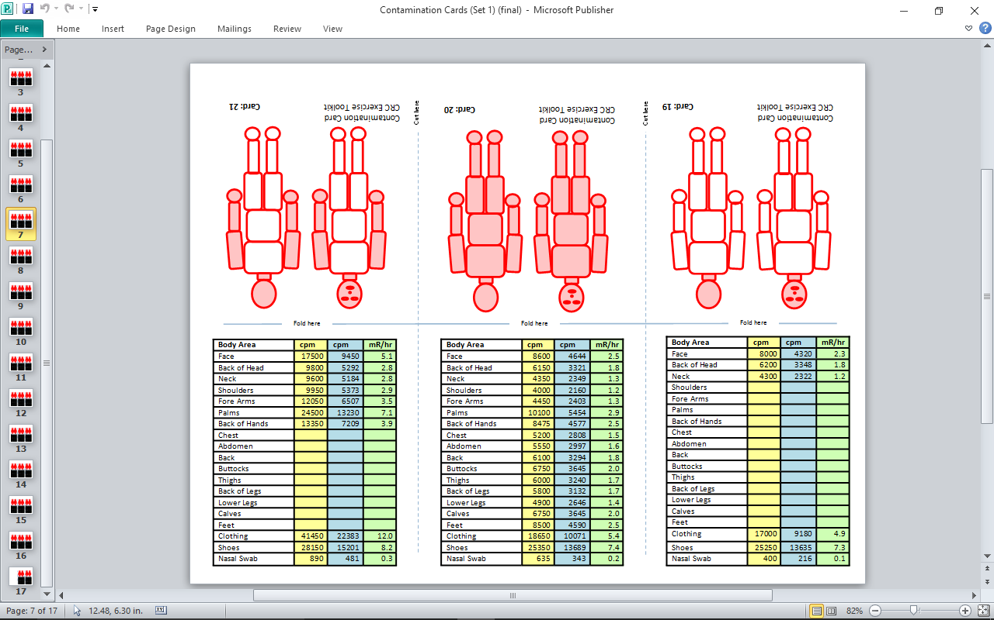

**Front of Card (Figure)**

1. The blocks that are shaded indicate the contaminated areas of the body. The quick geographical reference will help the controller focus on the contaminated areas being monitored.
2. The unshaded blocks are uncontaminated, and the controller will report the level as “As Read.”
3. The cards provided in the Toolkit are numbered, and an Excel spreadsheet provides an index to allow the drill planners to select specific cards if they do not plan to use the cards as sets.

**Back of Card (Table)**

1. The first column represents the body parts that are contaminated. They correspond to the blocks on the front of the card.
2. The second (yellow) column represents instruments that report count rates (cpm) with higher efficiency, such as a pancake GM probe.
3. The third column (blue) is for instruments that reports count rates (cpm) with lower efficiency, such as an end-window or hotdog GM probe.
4. The fourth (green) column is for meter readings on instruments that report exposure rates (mR/hr).
5. A nasal swab (or nose blown into a tissue) is counted to determine if internal contamination is likely. This is normally conducted when there is heavy contamination on the face, especially around the nose and mouth.

**Hint: Controllers should place a colored dot on the instruments prior to the start of the drill to easily identify the corresponding column, especially if a variety of instruments will be used.**

1. For monitoring and decontamination drills under the Federal Emergency Management Agency’s Radiological Emergency Preparedness Program for nuclear power plants, the ratio of contaminated persons is usually about 33%.