[CRC Drill Name]

Actor Instructions

[Date]

[Sponsoring organization]

# Administrative Handling Instructions

1. The title of this document is [CRC Drill Name] Actor Instructions.
2. This document should be safeguarded, handled, transmitted, and stored in accordance with appropriate [sponsoring organization] directives. Reproduction, distribution, or release of this document, in whole or in part, without the prior approval of [name of person/drill organizers] is prohibited.
3. The Actor Instructions describe the roles and responsibilities of those who have volunteered to play the part of members of the public visiting the Community Reception Center.
4. The Drill Coordinators are:

[sponsoring organization main contact name, title, organization, address, phone, email]

[contact information for any other drill coordinators]

1. The Drill Planning Team members include:

|  |  |
| --- | --- |
| [Name] | [Organization] |
| [Name] | [Organization] |
| [Name] | [Organization] |
| [Name] | [Organization] |
| [Name] | [Organization] |
| [Name] | [Organization] |
| [Name] | [Organization] |
| [Name] | [Organization] |

**Contents**

Administrative Handling Instructions ii

Drill Overview 1

Actor Information and Guidance 2

Purpose 2

Drill Participants 2

Participating Organizations 3

What Will Happen during the Drill? 3

Simulation 4

Evaluation 5

Actor Debriefing 5

Feedback Forms 5

After Action Report/Improvement Plan 5

Drill Logistics 6

Schedule 6

Safety 6

Alcohol and Illegal Drugs 6

Smoking 6

Participant Logistics 6

Parking and Transportation 6

Security 6

Food and Drink 7

Restroom Facilities 7

Drill Identification 7

Instructions for Play 8

Drill Rules 8

Actor Instructions 8

Before the Drill 8

During the Drill 9

After the Drill 9

**Appendices**

Appendix A: Drill Schedule

Appendix B: Drill Site Maps

Appendix C: Example Actor and Contamination Cards

Appendix D: Actor Instructions — Summary Handout

# Drill Overview

|  |  |
| --- | --- |
| **Drill Name** | [Insert the formal name of drill, which should match the name in the document header] |
| **Drill Dates** | [Indicate the start and end dates of the drill. If only one day, include the start and end times.] |
| **Scope** | This is a drill, planned for [drill duration] at [drill location]. Play is limited to activities within the Community Reception Center (CRC) after the CRC has been activated and staffed. |
| **Mission Area(s)** | Response |
| **Core Capabilities** | Mass Care Services, Environmental Response/Health and Safety, Public Health and Medical Services, Public Information and Warning |
| **Main Objective** | The purpose of this drill is to evaluate player actions against current response plans and procedures for the elements of a response to a radiological incident that take place at a CRC. |
| **Threat or Hazard** | Radiological/nuclear incident |
| **Scenario** | An Improvised Nuclear Device (IND) detonates in a city 100 miles away; the population is evacuated to other communities, and CRCs are established to screen the evacuees for contamination and provide assistance, referrals, and information. |
| **Sponsor** | [Insert the name of the sponsor organization, as well as any grant programs being used, if applicable] |
| **Participating Organizations** | [List participating organizations; if lengthy, include just the primary organizations here and the full list of participating agencies in Appendix B.] |
| **Point of Contact** | [Insert the name, title, agency, address, phone number, and email address of the primary drill point of contact (e.g., drill director or sponsor)] |

# Actor Information and Guidance

Thank you for volunteering to participate as an Actor in the [CRC Drill Name]! Your participation will help us hold a realistic drill that gives players an opportunity to exercise their emergency response capabilities. Without your assistance, this drill would not be possible.

You will be playing the role of a member of the general public who has been advised to go to a Community Reception Center (CRC) for registration, radiation screening, possible decontamination, and other assistance after a radiological/nuclear incident in your city. These Actor Instructions are intended to help you understand your role in the drill and to enable you to play your part effectively. This information will be reviewed during the actor orientation prior to the start of drill play, when you may also ask questions.

## Purpose

This CRC Drill is designed to establish a learning environment for players to exercise emergency response plans, policies, and procedures as they pertain to operating a CRC. The drill serves as a training tool and helps identify strengths and areas for improvement.

A CRC performs the following elements:

* Receives, registers and tracks potentially contaminated persons.
* Screens the affected population for external contamination.
* Decontaminates persons with identified external contamination
* Provides first aid for minor injuries.
* Provides psychosocial first aid as needed
* Refers individuals for additional medical, psychological, or health physics assistance as necessary.
* Addresses the communication and information issues related to the operation of the CRC.

## Drill Participants

The CRC Drill will include the following types of participants:

* **Players.** Players are participating agency personnel who have an active role in responding to the simulated emergency. Players will perform their regular and/or assigned roles and responsibilities in the CRC during the drill. During [this drill], the players are from [organization name(s)].
* **Actors.** Volunteer actors will simulate specific roles during drill play. They will play the role of survivors or others affected by the incident who have been advised to go to the CRC, or who have decided to self-report, following detonation of an IND in their town. A controller will be assigned to manage this group.
* **Controllers.** Controllers set up and operate the drill site, plan and manage drill play, and direct the pace of drill play. Controllers may deliver “injects” to drive certain player actions. The Actor Controller will provide instructions to the actors regarding their roles.
* **Simulation Cell (SimCell).** The SimCell simulates interactions with nonparticipating organizations that would likely participate actively if drill events were real. The SimCell may also simulate other events or activities to drive play.
* **Evaluators.** Evaluators evaluate and provide feedback on their assigned part of the CRC. They will observe, assess, and document player performance against the emergency plans and procedures established for the CRC. Information provided by evaluators forms the basis for the findings and recommendations in the After-Action Report (AAR). They will not provide feedback to players during the drill.
* **Observers.** Observers visit or view selected segments of the drill. Observers do not play in the drill, nor do they perform any control or evaluation functions. Observers will view the drill from a designated observation area and must remain within the observation area during the drill. During this drill, observers are expected from [organization name(s)]. [Delete bullet if not applicable]
* **Media.** Some members of the media are expected to be present during the drill. They have been instructed not to speak with players or actors but to remain in a designated observation area. [Delete bullet if not applicable]
* **Support Staff.** The drill support staff includes individuals who perform administrative and logistical support tasks during the drill (e.g., registration, catering).

## Participating Organizations

The following organizations are participating in the drill:

* [organization name and role]
* [organization name and role]
* [organization name and role]

## What Will Happen during the Drill?

This CRC Drill is intended to cover the activities at the CRC once it has been activated, set up, and staffed. Play begins immediately before the arrival of the first members of the public to the CRC. As an actor, you will play one or more of these individuals.

To tell you about your role, a controller will give you two cards: an **Actor Card** and a **Contamination Card** (see Appendix C for examples):

* The **Actor Card** will tell you the age, gender, and other demographic information associated with your role as well as what behaviors or symptoms you are to display as that particular individual. Actor Cards are used to drive specific situations or conditions requiring player response. In some cases, the Actor Card may instruct you to basically portray yourself. In many other cases, Actor Cards may call for a greater level of acting. For example, you may be directed to portray someone who does not speak English, has special needs, is a child or has children, is upset or belligerent, or any of a number of other possibilities CRC staff might encounter in a real emergency situation. The CRC staff playing in this drill will address and assist your character and your situation as called for in the plans, procedures, and protocols for the CRC.
* The **Contamination Card** specifies your contamination levels, if any. When CRC staff use radiation detection equipment to check you for contamination, you will hand this card to the Radiological Controller; he or she will provide simulated instrument readings to the CRC staff based on their correct use of the radiation detection instruments. The card may identify you as having no contamination, or it may identify that you have contamination of a particular level on all of a part of your body. The CRC staff players will give you instructions on whether and how you should be decontaminated as well as next steps.

To the extent that your Actor Card includes relevant information, please use this to complete the registration form. Otherwise, you may make up the information necessary to complete the form.

Please follow the instructions that CRC staff give you throughout the drill, unless your Actor Card or a controller directs you otherwise. Please play the role assigned to you fully, but do not go beyond it. If the CRC staff players do not recognize your symptoms or the situation you are trying to portray, you can increase the intensity of your symptoms, agitation, etc. as it might occur in real life. CRC staff players will be implementing actions as they would in real life, within the areas marked for play. The players will take the situation seriously; so should you. If you have concerns with what you are asked to do, please bring them to the attention of the Actor Controller, whom you will meet during Actor Orientation.

After you complete your time in the CRC and pass through the Discharge Station, return to the Actor Controller to turn in your cards. Depending on the size of the drill, you may then receive a new set of cards so that you can proceed again, in a different role, through the CRC.

## Simulation

Although players will perform as though the situation is real, certain details will be simulated. These include some player actions: [add/delete/qualify as needed]

* Players will use the appropriate radiation detection equipment according to procedure.
* Actors playing individuals requiring decontamination [will/will not] actually shower. [Add if needed: If you are required to shower, you will be instructed, prior to the drill, to wear appropriate swimwear under your clothing.]
* Individuals may be referred to internal dose assessment, but no actual assessment activities will take place and the individual will then proceed to registration.
* Individual actors may tell players that they have pets, but actual pets will not be present. [The Drill Planning Team will determine if actual animals are to be used and if waivers and precautions are required.]
* A player may identify that a member of the public needs first aid and will take that person to that station or have first aid staff summoned, but no actual first aid activities will take place.
* [other]

Otherwise, players will conduct operations as normally as possible and proceed to respond as called for in CRC plans, procedures, and protocols until stopped by the controller or evaluator.

## Evaluation

The goal of drill evaluation for the CRC Drill is to validate strengths and identify improvement opportunities for the participating organization(s). Because jurisdictions are testing new and emerging plans, skills, resources, and relationships in response to a changed homeland security environment, every drill, exercise, or event can be expected to result in multiple findings and recommendations for improvement.

### Actor Debriefing

Because actors in the drill have a unique vantage point (you are the people who are on the receiving end of CRC operations), it is important to gather your feedback and tap your insights. At the conclusion of drill play, the Actor Controller will facilitate a debriefing/discussion to allow actors to discuss your experiences, share your insights, and express your opinions about the drill. This will take place at the same time as the Hot Washes for the individual stations and before the drill-wide Hot Wash (actors do not participate in this Hot Wash).

### Feedback Forms

Actors will receive an Actor Feedback Form to complete and return to the Actor Controller. This form gives you an opportunity to comment candidly and provide your observations of the emergency response activities and drill effectiveness.

### After Action Report/Improvement Plan

The evaluators will compile an After-Action Report (AAR) based on their observations, the input of controllers and players, and the information in the Participant Feedback Forms. The AAR will include a rating of how the drill players performed, as well as strengths, areas for improvement, and recommendations. Local officials will review this report and identify corrective actions to resolve areas identified for improvement and to implement recommendations as appropriate.

# Drill Logistics

## Schedule

This CRC Drill will be conducted on [date], beginning at [time]. Appendix A provides the detailed schedule for the drill, including time and location for actor check-in and assembly. Drill play is scheduled for [duration] or until the Drill Director and Lead Controller determine that the drill objectives have been met at each station. The Drill Director will announce the start of the drill. The Drill Director will announce drill suspension or termination and will instruct participants to stop in place safely.

## Safety

If an actual emergency occurs, the drill may be suspended or terminated at the discretion of the Drill Director, depending on the nature of the incident. The designated phrase in case of a medical or other emergency is “**real-world emergency**.” The Drill Director will announce resumption of the exercise.

### Alcohol and Illegal Drugs

Alcohol consumption will not be allowed during the drill, and the use of illegal drugs is strictly prohibited.

### Smoking

Smoking is not permitted inside the CRC or indoor drill venues. Smoking may be allowed outdoors or at designated places indoors or outdoors. [Replace with the facility’s own policy.]

## Participant Logistics

### Parking and Transportation

Parking will be available at the drill sites. [Indicate if there are specific places evaluators, controllers, players, and actors should park and whether public transportation is available.]

### Security

[Indicate whether participants will need to go through the facility’s security in order to access the drill site.]

Access to drill sites, including participant waiting areas, is limited to drill participants. Staff at the drill registration table will control entry into the drill site, and only authorized personnel (including playing actors) will be permitted access into the drill play areas.

Drill documents are intended for the use of the drill planners and participants and are not to be released or distributed without prior approval from the drill organizers [or list specific name].

Photos of drill players, actors or activity may not be taken, distributed, released, or posted (including on social media) without permission of the drill organizers.

### Food and Drink

[Indicate what refreshments are available for all drill participants and where they are located; indicate whether they will need to bring their own meal(s) or whether they should expect to go to a cafeteria or off site for a meal.]

### Restroom Facilities

[Indicate the location of restroom facilities for all drill participants and whether they are separate from those used by the CRC.]

### Drill Identification

Identification badges will be issued to all drill participants at the registration table. These badges must be worn at all times. The chart below describes these badges.

|  |  |  |  |
| --- | --- | --- | --- |
| **Group** | **Badge** | **Group** | **Badge** |
| Controllers | Green | Players | Yellow |
| Evaluators | Red | Media | Pink |
| Observers | Blue | Actors | Orange |
| Support Staff | Brown |  |  |

# Instructions for Play

## Drill Rules

The following general rules govern drill play:

* + The Drill Director will initiate and end drill play.
* All drill messages and communications made by telephone, email, radio, or in writing will begin and end with the phrase, “**This is a drill.**”
* Controllers can temporarily stop drill play for any reason by saying “**Time out.**”
* Real-world emergency actions take priority over drill actions. In the event of a real emergency, say “**This is a real-world emergency.**”
* If a real emergency occurs during the drill, controllers will immediately suspend drill play and evaluate the situation. The Drill Director and Safety Controller will then decide if the drill can be safely resumed.
  + Drill participants will comply with real-world emergency procedures, unless otherwise directed by the control staff.
  + All participants must understand the scope of the drill. Anyone unsure about their role in the drill should ask (actors should work with the Actor Controller).
  + Participants should accept that parts of the scenario may seem implausible. The drill has objectives that must be satisfied and may require doing things that may not be as realistic as expected.
  + Except for actions identified in the list of actions to be simulated, or as otherwise directed by drill controllers, players will respond to drill events and information as if the emergency were real.

## Actor Instructions

### Before the Drill

* Sign in at the registration table when you first arrive to obtain your badge.
* Follow the directions given to you at registration to meet the rest of the actors and the Actor Controller.
* Review the Actor Instructions and attend the required orientation.
* Report to your assigned area at the time designated by the Actor Controller.

### During the Drill

* Wear assigned identification items (e.g., badge). Actor badges will be issued at check-in.
* Avoid personal conversations with drill players, controllers, and evaluators; stay in character.
* Follow the instructions of the Actor Controller.
* Play the role indicated on your Actor Card; do not overact but do make your actions obvious enough that CRC staff have an opportunity to take notice.
* Do not ad lib (make up) symptoms or situations not on your Actor Card or directed to you by a controller.
* Do not prompt the CRC staff players.
* Cooperate with CRC staff players, except as directed by an Actor Card or controller.
* Actually perform the needed actions, except as noted above under Simulation or as directed by a controller or evaluator.
* If you notice anyone (observers, members of the media, or others) in the drill play area outside of their designated areas, notify drill staff (controller, evaluator, support staff, or Drill Director).
* If there is a problem, or you do not feel well, tell the nearest CRC staff player, controller, or evaluator “**This is a real emergency.**”

### After the Drill

* Return to the assembly area (or other location as directed by the Actor Controller) after the drill.
* Participate in the actor debriefing.
* Complete and submit an Actor Feedback Form. Turn this in to the Actor Controller.
* Thank you for your role in making the drill a success!

Appendix A: Drill Schedule

| **Time** | **Personnel** | | | **Activity** | **Location** | |
| --- | --- | --- | --- | --- | --- | --- |
| [Date. Time] | | Players | Pre-Event Player Training | | | [Location or electronic] |
| [Date, Time] | | Actors | Pre-Event Actor Training | | | [Location or electronic] |
| [Date, Time] | | Controllers, evaluators, and support staff | Pre-Event Controller and Evaluator Training | | | [Location] |
| **[Date]** | | | | | | |
| [Time] | Support staff | | | Set up and stage CRC facility | [Location] | |
| **[Date]** | | | | | | |
| [Time] | Controllers, evaluators, and exercise staff | | | Check-in for final instructions and communications check | [Location] | |
| [Time] | Players | | | Check-in for final instructions | [Location] | |
| [Time] | Actors | | | Check-in for final instructions | [Location] | |
| [Time] | Media | | | Media Briefing | [Location] | |
| [Time] | VIPs and selected exercise staff | | | VIP Briefing | [Location] | |
| [Time] | All participants | | | Exercise briefing | [Location] | |
| [Time] | All players | | | Staff briefing | [Location] | |
| [Time] | All participants | | | All participants take their stations | [Location] | |
| [Time] | All participants | | | Exercise starts | [Location] | |
| [Time] | All players | | | Staff briefing | [Location] | |
| [Time] | All players | | | Evacuees (Actors) arrive at CRC | [Location] | |
| [Time] | All participants | | | Exercise ends | [Location] | |
| Immediately After the Drill | Players, controllers, and evaluators | | | Hot Wash, turn in all Participant Feedback Forms | [Location] | |
| Immediately After the Drill | Actors | | | Actor Debriefing | [Location] | |
| Immediately After the Hot Wash | Players, controllers, and evaluators | | | Site Breakdown/Cleanup | [Location] | |
| Immediately After Cleanup | Controllers and evaluators | | | Controller and evaluator debriefing, complete EEGs | [Location] | |
| **[Date]** | | | | | | |
| [Time] | Controllers, evaluators, and elected and appointed officials | | | After Action Meeting | [Location] | |

Appendix B: Drill Site Maps

Figure B.1: [Map Title]

[Insert map]

Figure B.2: [Map Title]

[Insert map]

Appendix C: Example Actor and Contamination Cards

Sample Actor Card

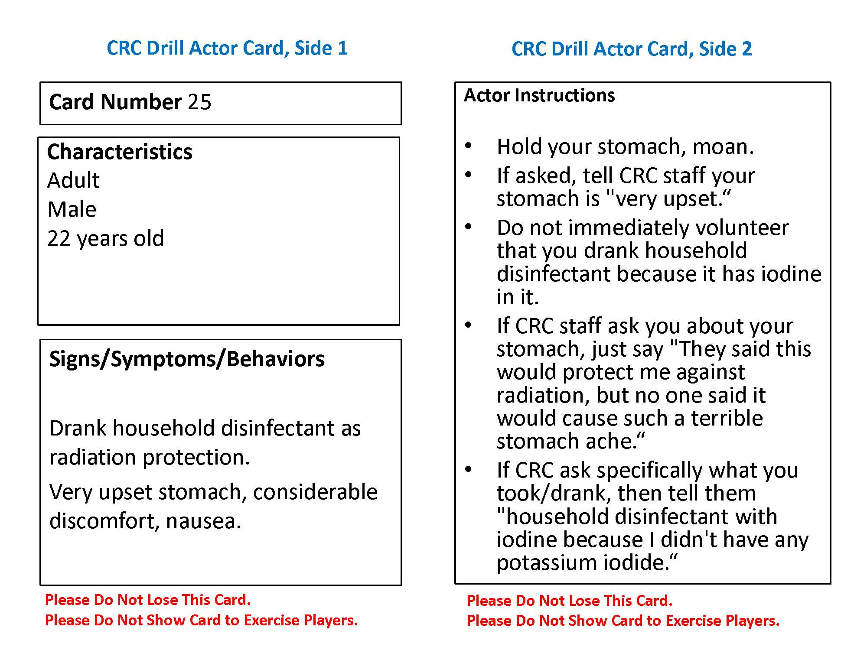

Sample Contamination Card

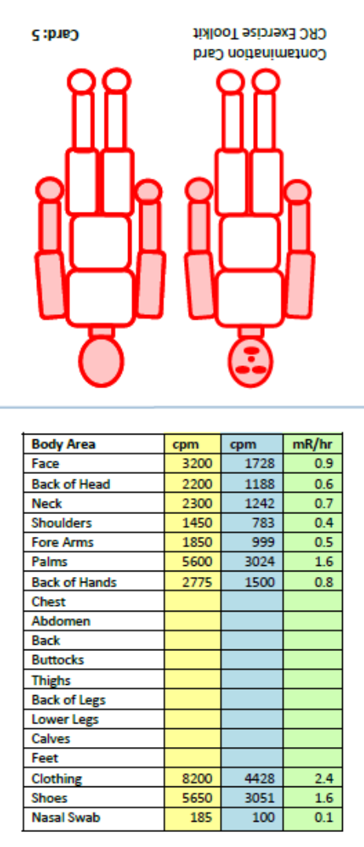CRC Drill Contamination Card, Side 1 CRC Drill Contamination Card, Side 2

Appendix D: Actor Instructions – Summary Handout

**[CRC Drill Name] Actor Instructions**

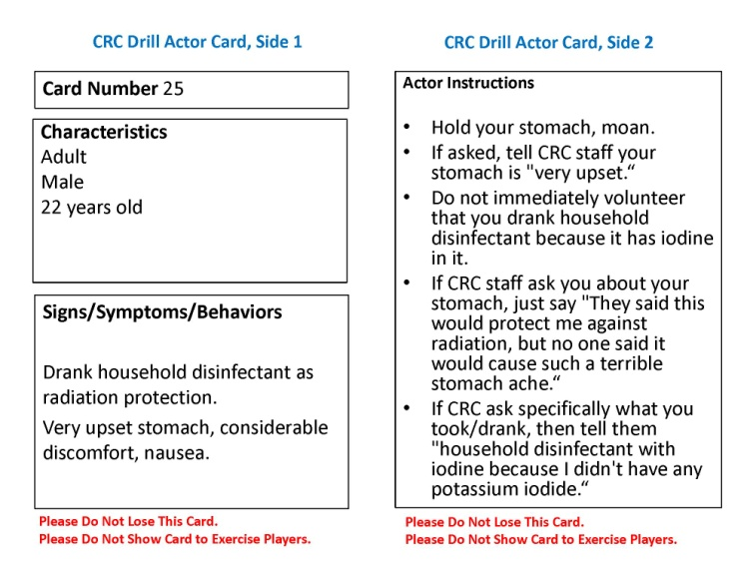Thank you for volunteering to be an actor in today’s drill. You will play the role of a member of the general public who has been advised to go to a Community Reception Center (CRC) for radiation screening after a large radiological/nuclear incident in your city. You may be asked to go through the process one or more times to simulate a large population attending the CRC. You will receive two cards each time you enter the CRC process: an Actor Card and a Contamination Card. The two cards, explained below, provide all the information you need to play your role effectively. After you complete the CRC process, turn in your cards to the Actor Controller and, if appropriate, receive a new set.

The **Actor Card** tells you the characteristics of the person you are playing (e.g., age, gender) as well as any behaviors or symptoms the person is exhibiting or experiencing. Play the role to the best of your ability – do not overplay the role. If you are unsure how to play the role, or have any questions, ask the Actor Controller.

**CRC Drill Actor Card**

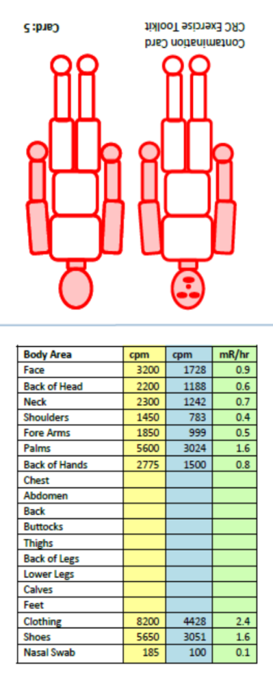The **Contamination Card** contains information about the person’s level of contamination, if any. When CRC staff use radiation detection equipment to check you for contamination, hand the Contamination Card to the Radiological Controller and he or she will simulate the readings. The CRC staff players will instruct you on next steps.

**CRC Drill Contamination Card**

Please follow the instructions that CRC staff players give you throughout the drill, unless your Actor Card directs you otherwise. Play the role assigned to you fully, but do not over act or ad lib symptoms or situations not written on the Actor Card.

Although players will perform as though the situation is real, certain details will be simulated. Controllers will direct CRC staff players when to stop play. For example,

* Individuals identified as requiring decontamination will not actually shower.
* A player may identify that an individual needs first aid and be taken to that station or have first aid staff summoned, but no actual first aid activities will take place.

**Have fun with it!**